Lab Experiment #3

ECE 282 - 002

Friday PM Lab

Carlos Sanchez and Connor Raasch

Laboratory Experiment #4 Pre-Lab

1. Design a three-input Majority Circuit and use a K-Map to obtain the simplified Boolean Function. Please include an electronic Logic Diagram including power, ground, pin and part numbers (same as labs 1 & 2).

| X | Y | Z | F |
| --- | --- | --- | --- |
| 0 | 0 | 0 | 0 |
| 0 | 0 | 1 | 0 |
| 0 | 1 | 0 | 0 |
| 0 | 1 | 1 | 1 |
| 1 | 0 | 0 | 0 |
| 1 | 0 | 1 | 1 |
| 1 | 1 | 0 | 1 |
| 1 | 1 | 1 | 1 |

|  | YZ | Y'Z' | Y'Z | YZ | YZ' |
| --- | --- | --- | --- | --- | --- |
| X |  |  |  |  |  |
| X' |  | 0 | 0 | 1 | 0 |
| X |  | 1 | 1 | 1 | 1 |

F = XY + XZ + YZ

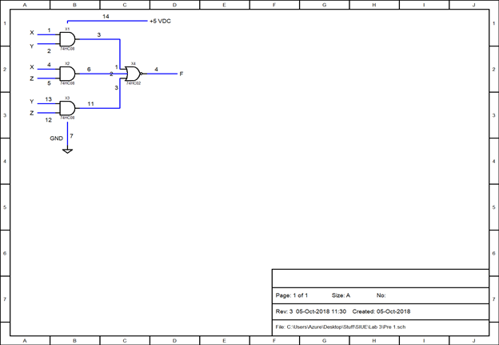

2. Design the combinational circuit for a Seven-Segment Display as was discussed in class. Use K-Maps to determine the simplified Boolean Functions. Please provide the entire Logic Diagram for the circuit. It doesn’t have to be electronic but should be drawn clearly and professionally. It DOES NOT need to include inverters.

Laboratory Experiment #4

1. Work ‘Majority Logic’ on p.567. Construct the circuit and demonstrate its operation to the TA. Include your design from the pre-lab as well as a printout of the waveforms of the circuit’s operation using the oscilloscope in the Lab Report.

Summary:

In this lab, we hooked up the Majority Circuit only using NAND gates. We’ve done this previously in another lab, except we didn’t use NAND gates. Figuring it out and implementing the circuit went smoothly.

2. Work ‘Seven-Segment Display’ on p.569. Construct the circuit using the display and decoder included in your parts kit (74LS48 which isn’t the same as the one discussed in the text……it uses negative logic) and demonstrate its operation to the TA. Include the Circuit Diagram (as discussed in class) as well as your design from the pre-lab in the Lab Report.

Summary:

For part 2 of this lab, we used the circuit design for the display in our prelab to construct the seven-segment display. We used the binary counter and hooked it up to the decoder which was connected to the display. Once this circuit worked and counted from 0-15, we then used NAND gates to make the counter reach 9, and then become blank after 9. We had hiccups with this step, but we managed to successfully stop the counter at 9.